Assignment # 2
Misha Mansoor
1353
BSCS-6TH Morning
Numerical analysis
20 March 2018

Algorithms for False Position
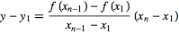
with , using , and solving for therefore gives the iteration
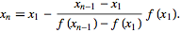

Secant Method Algorithm:
- Start
- Get values of x0, x1 and e
*Here x0 and x1 are the two initial guesses
e is the stopping criteria, absolute error or the desired degree of accuracy*
- Compute f(x0) and f(x1)
- Compute x2 = [x0*f(x1) – x1*f(x0)] / [f(x1) – f(x0)]
- Test for accuracy of x2
If [ (x2 – x1)/x2 ] > e, *Here [ ] is used as modulus sign*
then assign x0 = x1 and x1 = x2
goto step 4
Else,
goto step 6
- Display the required root as x2.
- Stop
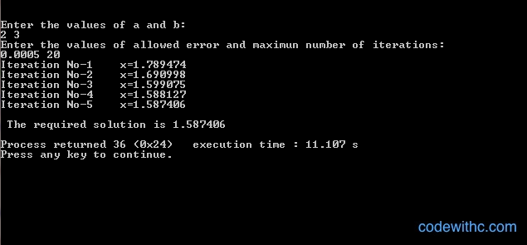

Algorithm: Bisection method
Start
- Decide initial values for x1 and x2 and stopping criterion, E.
- Compute f1 = f(x1) and f2 = f(x2).
- If f1 * f2>0, x1 and x2 do not bracket any root and go to step 7;
Otherwise continue.
- Compute x0 = (x1+x2)/2 and compute f0 = f(x0)
- If f1*f0 < 0 then
set x2 = x0
else
set x1 = x0
set f1 = f0
- If absolute value of (x2 – x1)/x2 is less than error E, then
root = (x1 + x2)/2
write the value of root
go to step 7
else
go to step 4
- Stop.

Newton Raphson Method Algorithm:
- Start
- Read x, e, n, d
*x is the initial guess
e is the absolute error i.e the desired degree of accuracy
n is for operating loop
d is for checking slope*
- Do for i =1 to n in step of 2
- f = f(x)
- f1 = f'(x)
- If ( [f1] < d), then display too small slope and goto 11.
*[ ] is used as modulus sign*
- x1 = x – f/f1
- If ( [(x1 – x)/x1] < e ), the display the root as x1 and goto 11.
*[ ] is used as modulus sign*
- x = x1 and end loop
- Display method does not converge due to oscillation.
- Stop
